**Project Documentation**

Fitflex:Your Personal Fitness Companion

1. **Introduction**
2. **Project Title :** Fitflex – your personal fitness companion
3. **Team ID:** NM2025TMID41029
4. **Team leader** : R.Sakthi sree & 24bca43acas@gmail.com
5. **Team members:**

1.Saisharan.R & 24bca42acas@gmail.com

2.Reena.S & 24bca41acas@gmail.com

3.Irfana banu.H & 24bca14acas@gmail.com

**2.Project overview**

* **Purpose:** Fitflex helps you track,manage,and improve your fitness journey with personilized insights
* it acts as your all-in-one guide for workouts, nutrition, and lifestyle balances
* **Features:**

**-** Personalized workout plans tailored to your goals.

**-**Smart nutrition tacking with meal suggestions.

**-**Progress monitoring through analytics and reports.

**-**Intregration with wearables for real-time data.

**-**Motivational reminders and community challenges.

**3.Architecture**

**•Frontend:** React.js with Bootstrap and Material UI

**•Backend:** Node.js and Express.js managing server logic and API endpoints

**•Database:** MongoDB stores user data, project information, applications, and chat messages

**4. Setup Instructions**

**•Prerequisites:**

–Node.js

–MongoDB

–Git

–React.js

–Express.js – Mongoose – Visual Studio Code

**•Installation Steps:**

# Clone the repository git clone

# Install client dependencies cd

client npm install

# Install server dependencies cd

../server npm install

**5. Folder Structure**

SB-Works/

|-- client/ # React frontend

|__components/

L__ pages/

|__ server/ # Node.js backend

|__routes/

|__ models/

|__ controllers/

**6. Running the Application**

**•Frontend:**

cd client

npm start

**• Backend:**

cd server npm

start

**•Access:** Visit http://localhost:3000

**7. API Documentation**

**•User:**

–/api/user/register

–/api/user/login

**•Projects:**

–/api/projects/create

–/api/projects/:id • Applications: /api/apply

**•Chats:**

–/api/chat/send

–/api/chat/:userId

**8. Authentication**

•JWT-based authentication for secure login

•Middleware protects private routes

**9. User Interface**

•Landing Page

•Freelancer Dashboard

•Admin Panel

•Project Details Page

**10. Testing**

•Manual testing during milestones

•Tools: Postman, Chrome Dev Tools

**11. Screenshots or Demo**

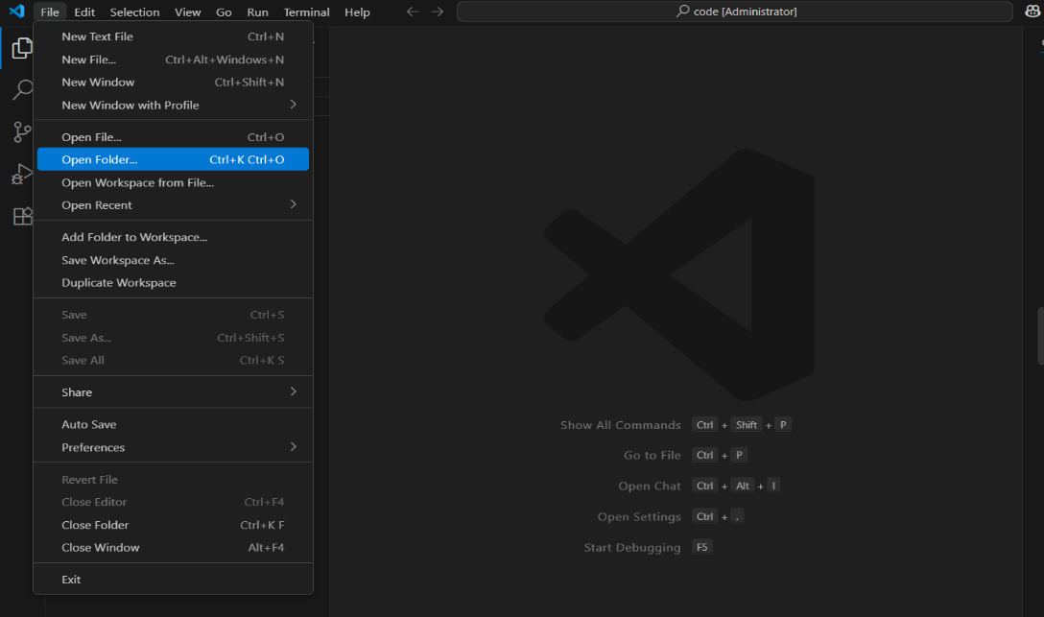

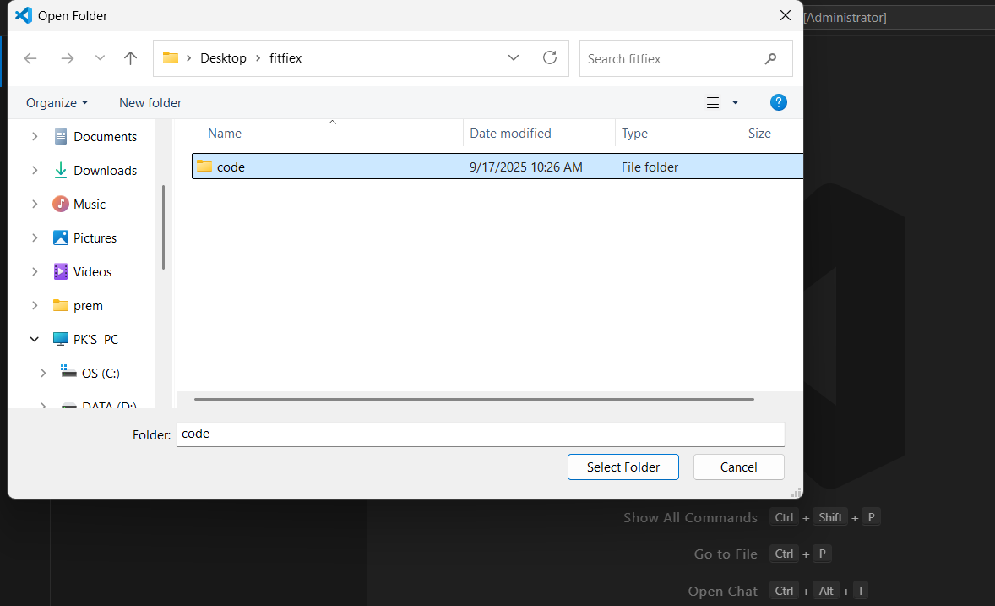

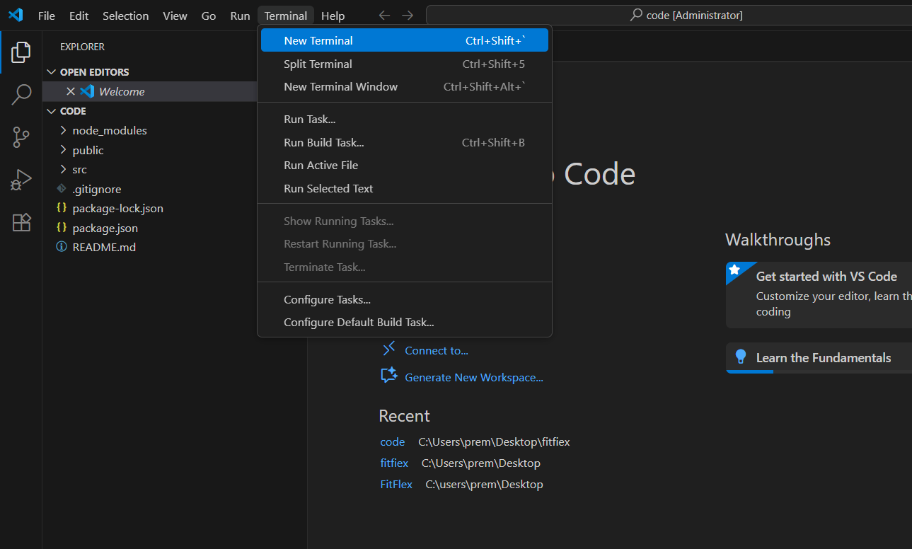

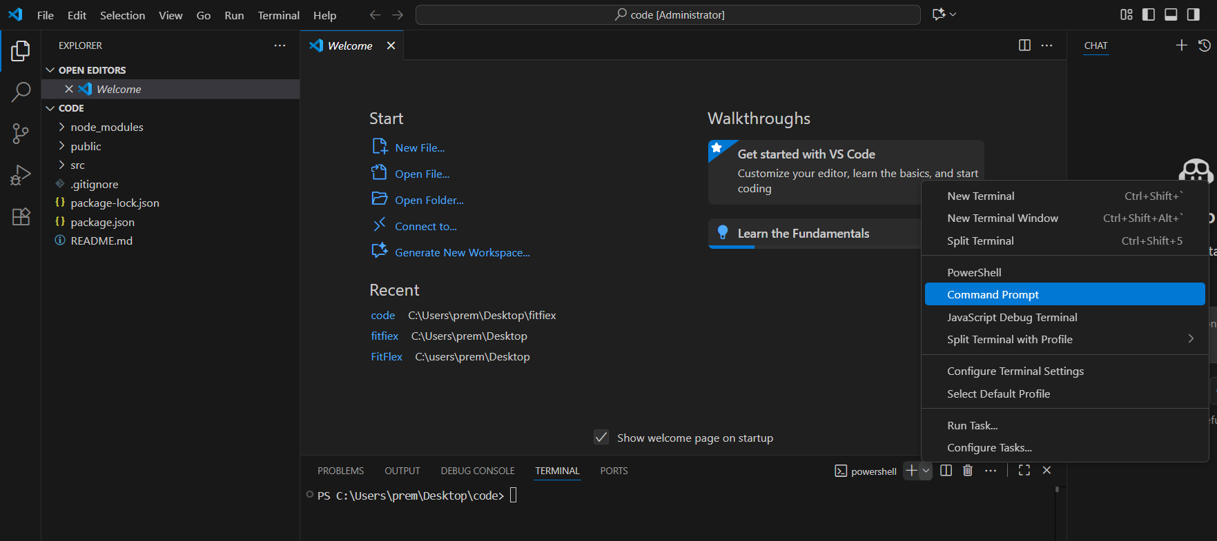

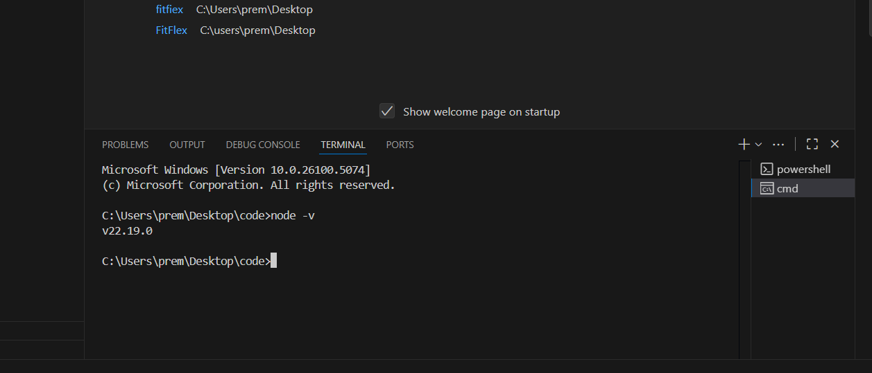

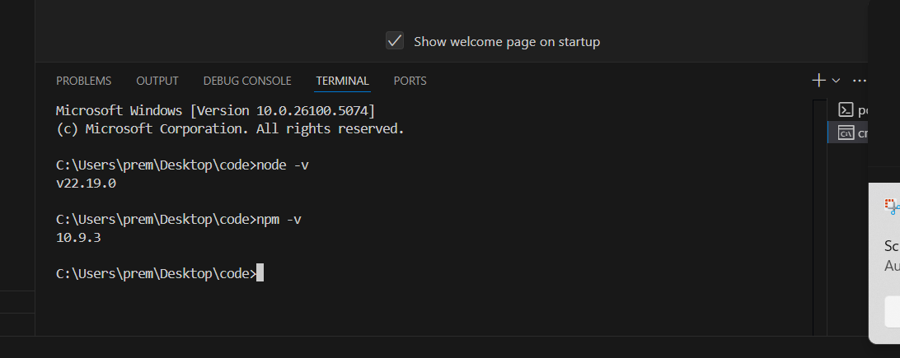

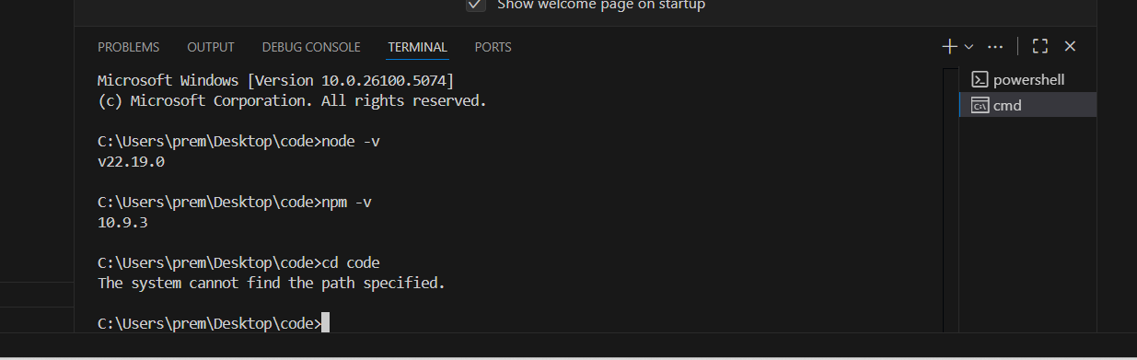

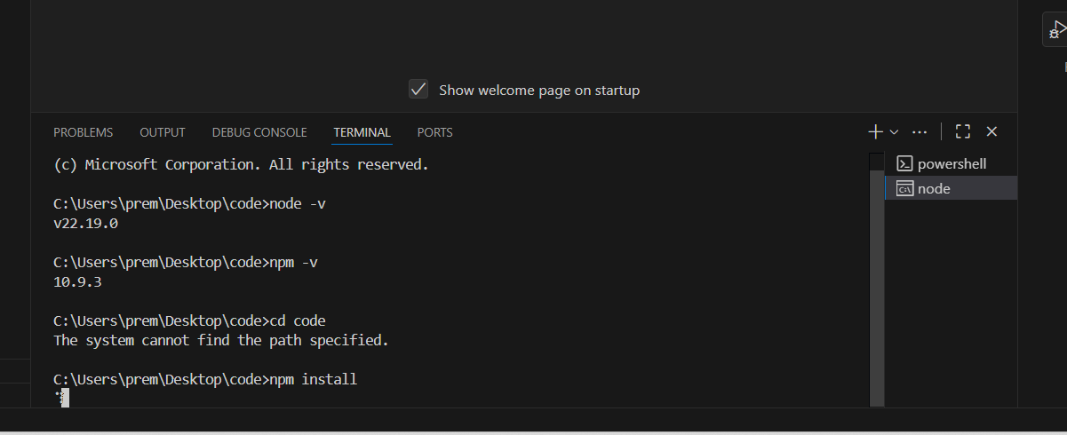

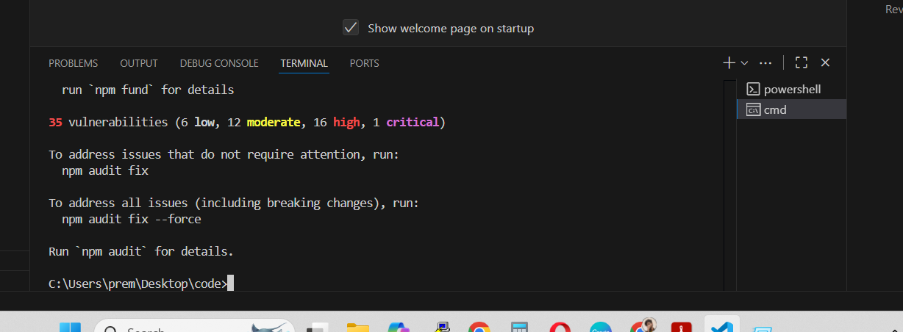

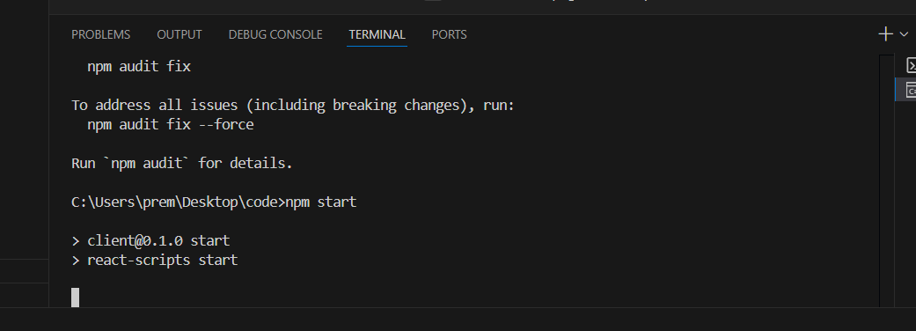

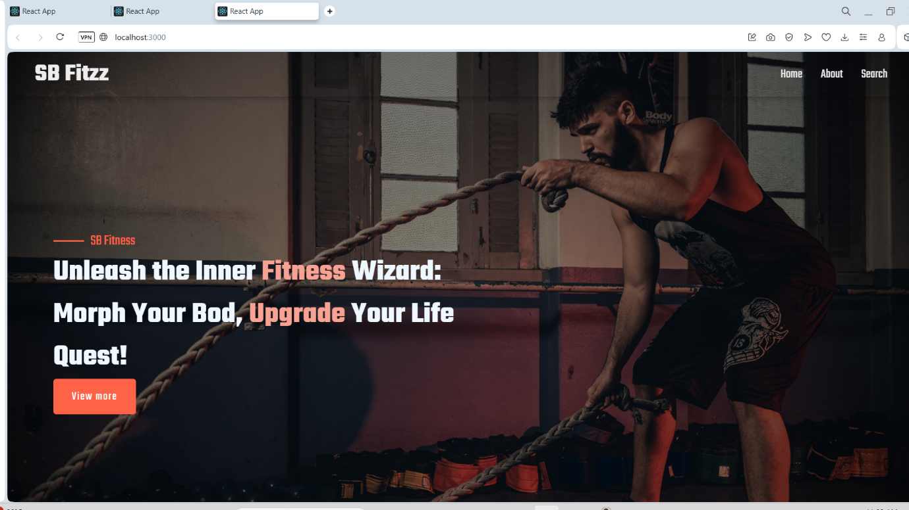

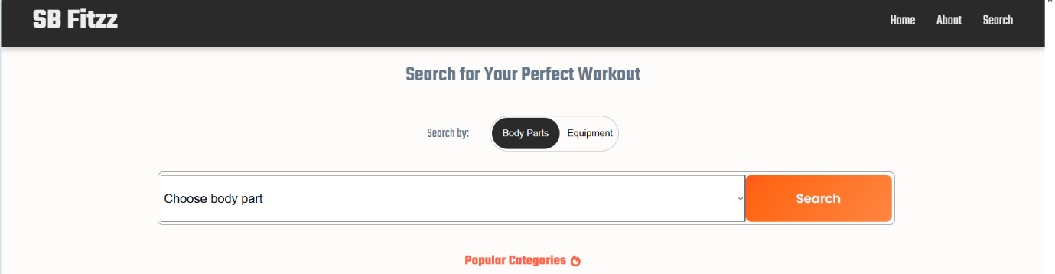

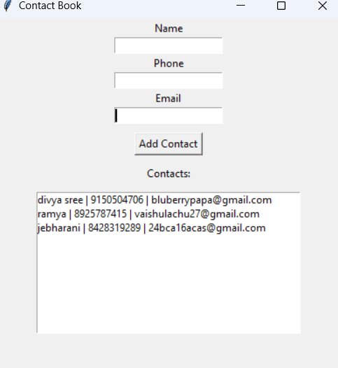

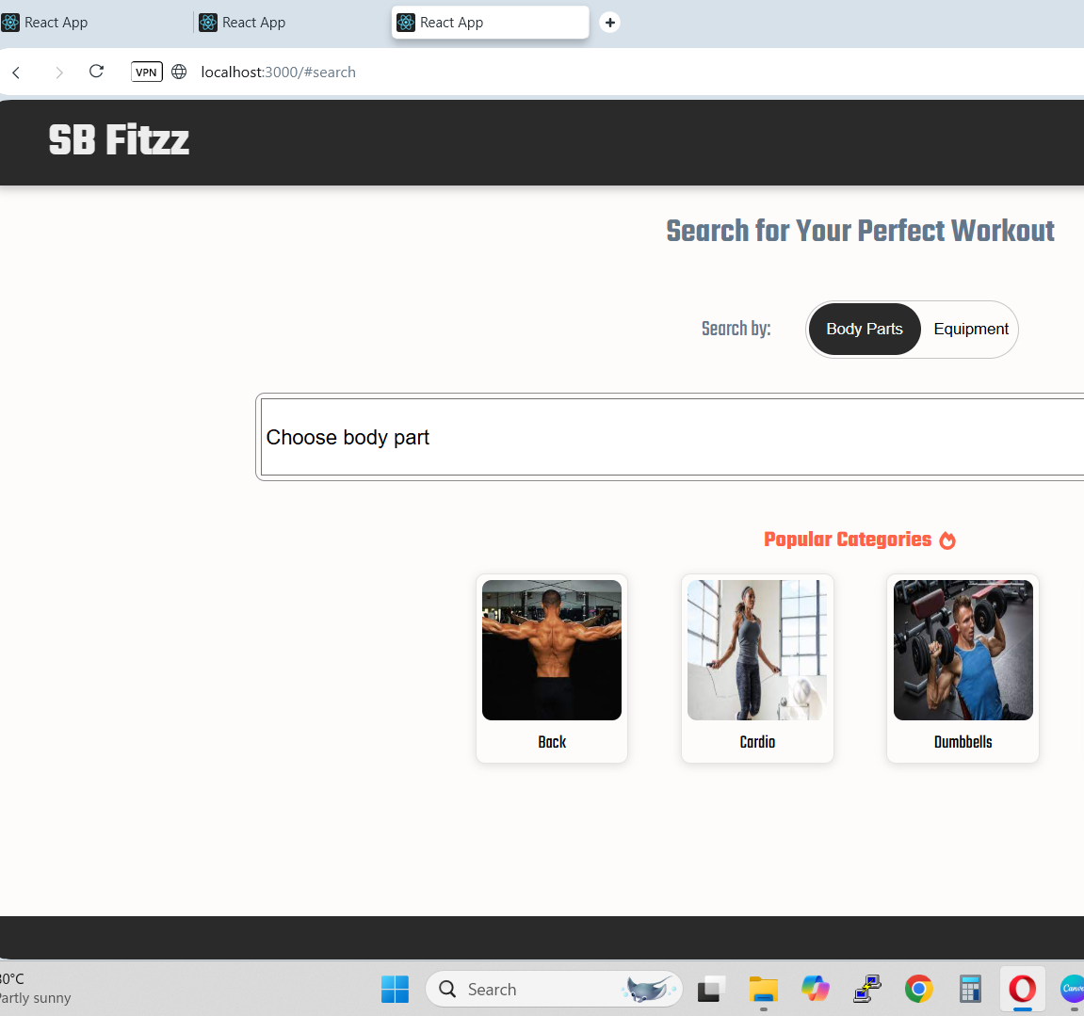

**12.Future enhancement**

* AI-Based workout recommendations.
* Adaptive difficulty.
* Nutrition integration.
* Streaks & achievement badges.
* Live workout sessions.
* Voice-guided workouts.
* VR fitness experiences.
* Detailed injury risk alerts.
* Hydration reminders & water intake tracking.